Testing financial analysis system API routes

Test 1: No-Prefix-Request
- Description: The financial analysis system requires the route be prefixed with ‘/finas/’, here test that when this requirement isn’t met an appropriate response is returned and the user is denied the response.

- Correct response: Unauthorised request (401) + Error message

- Request: `http://127.0.0.1:5000/queries/lookup`
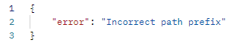
- Response:

- Test status: Passed

Test 2: Bad-Auth-Request
- Description: The financial analysis system requires the request container a header “Authorization” with the correct API key

- Correct response: Forbidden request (403) + Error message

- Request: ` http://127.0.0.1:5000/finas/queries/lookup` + Incorrect API key

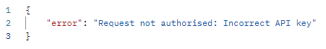
- Response:

- Test status: Passed

Test 3: Get-Queries-Lookup
- Description: Send GET request to get the queries lookup dictionary back from the API

- Correct response: Ok request (200) + Lookup dictionary

- Request: `http://127.0.0.1:5000/finas/queries/lookup`
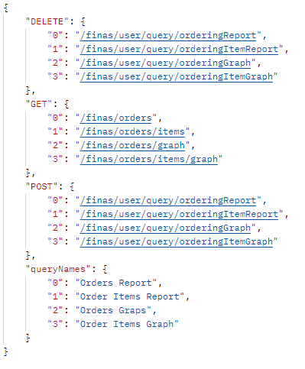
- Response:

- Test status: Passed

Test 4: Get-Users-Queries
- Description: Send GET request to get all queries belonging to a given user

- Correct response: Ok request (200) + List of query objects, example:
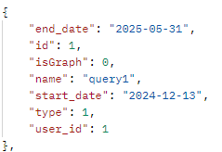

- Request: `http://0.0.0.0:5000/finas/user/queries?user_id=1`
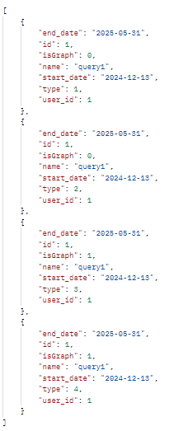
- Response:

- Test status: Passed

Test 5: Get-Users-Queries-OrderingReport
- Description: Send GET request to get all OrderingReport type (1) queries belonging to a given user

- Correct response: Ok request (200) +Query object of type 1, example:

- Request: `http://0.0.0.0:5000/finas/user/query/orderingReport?user_id=1&id=1`

- Response:

- Test status: Passed

Test 6: Get-Users-Queries-OrderingItemReport
- Description: Send GET request to get all OrderingItemReport type (2) queries belonging to a given user

- Correct response: Ok request (200) +Query object of type 2, example:

- Request: `http://0.0.0.0:5000/finas/user/query/orderingReport?user_id=1&id=2`

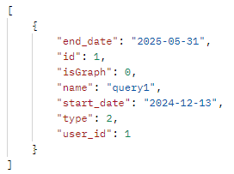
- Response:

- Test status: Passed

Test 7: Get-Users-Queries-OrderingGraph
- Description: Send GET request to get all OrderingGraph type (3) queries belonging to a given user

- Correct response: Ok request (200) +Query object of type 3, example:

- Request: `http://0.0.0.0:5000/finas/user/query/orderingReport?user_id=1&id=3`
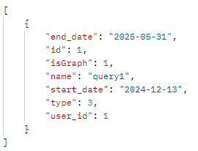
- Response:

- Test status: Passed

Test 8: Get-Users-Queries-OrderingItemGraph
- Description: Send GET request to get all OrderingItemGraph type (4) queries belonging to a given user

- Correct response: Ok request (200) +Query object of type 4, example:

- Request: `http://0.0.0.0:5000/finas/user/query/orderingReport?user_id=1&id=4`
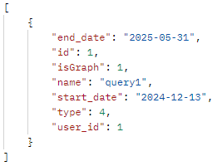
- Response:

- Test status: Passed

Test 9: Get-Orders
- Description: Send GET request to get all orders within a given date range

- Correct response: Ok request (200) + List of order objects, example:
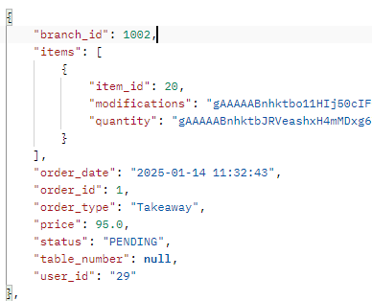

- Request: ` http://0.0.0.0:5000/finas/orders?start_date=2023-09-27&end_date=2026-12-29`

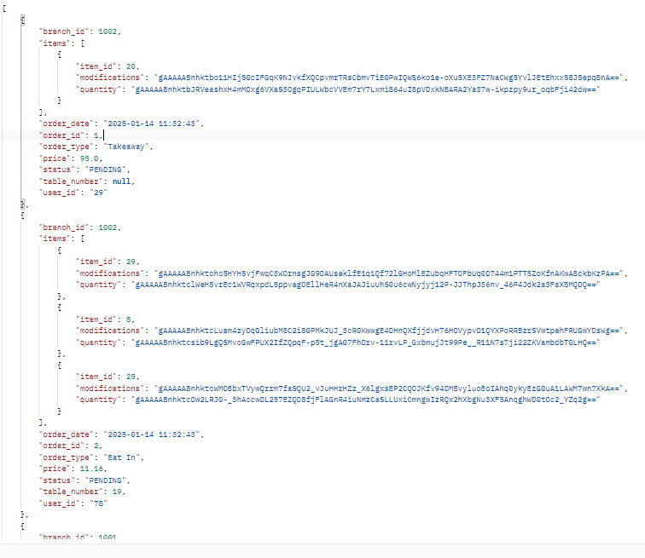
- Response:

- Test status: Passed - (However item information needs decryption)

Test 10: Get-Orders-Items
- Description: Send GET request to get all items and their order quantity within a given date range

- Correct response: Ok request (200) + List of items object types with quantity, example:
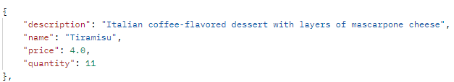

- Request: `http://0.0.0.0:5000/finas/user/query/orderingReport?user_id=1&id=4`
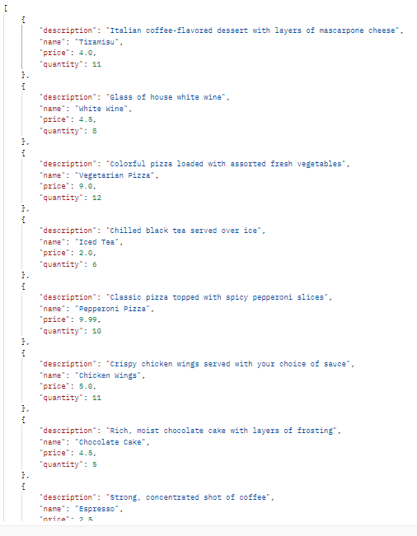
- Response:

- Test status: Passed

Test 11: Get-Orders-Graph
- Description: Send GET request to get graph of order quantity over a given date range

- Correct response: Ok request (200) + Order graph:

- Request: `http://localhost:5000/finas/orders/graph?start_date=2025-01-01&end_date=2025-12-29&user_id=1

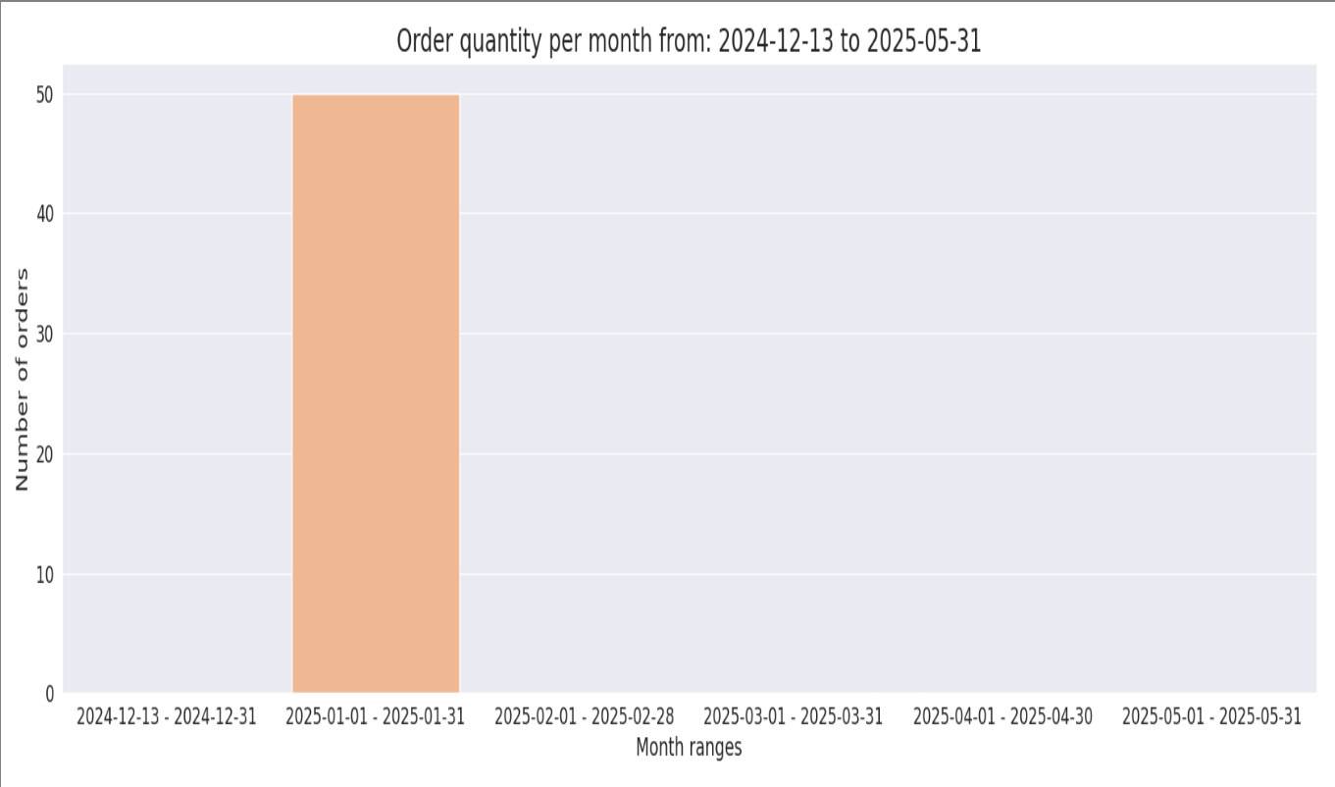
- Response:
- Test status: Passed

Test 12: Get-Orders-Items-Graph
- Description: Send GET request to get graph item order quantity over a given date range

- Correct response: Ok request (200) + Order item graph:

- Request: ` http://127.0.0.1:5000/finas/orders/items/graph?start_date=2023-09-27&end_date=2026-12-29&user_id=1`

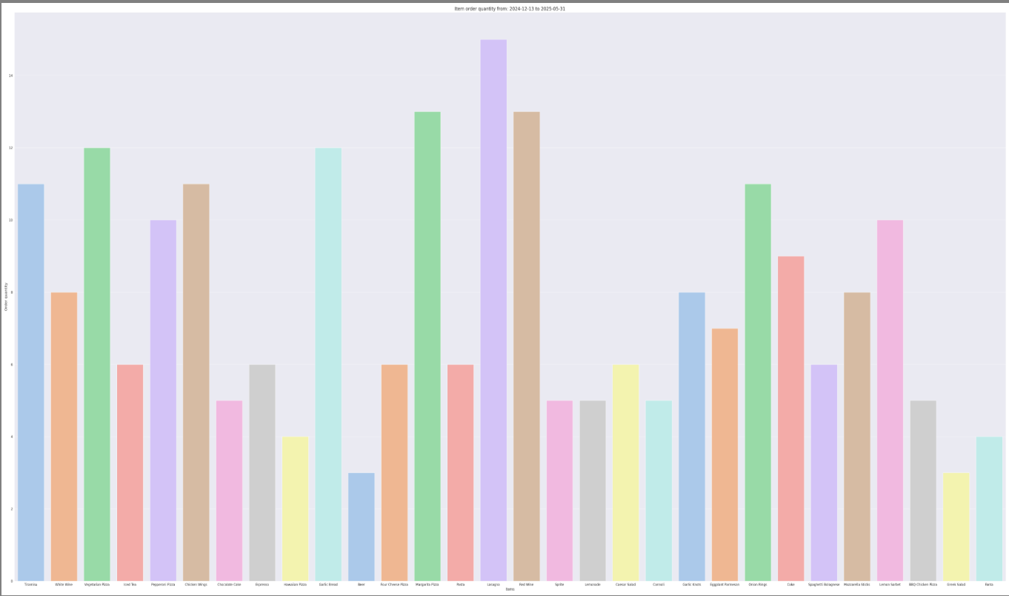
- Response:
- Test status: Passed

Test 13: POST-Orders-Report
- Description: Send POST request to save new OrderingReport type (1) query

- Correct response: Ok request (200) + Save confirmation:

- Request: ` http://127.0.0.1:5000/finas/user/query/orderingReport` + body:
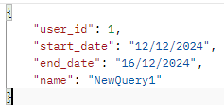

- Response:
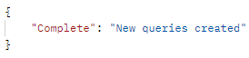

- Test status: Passed

Test 14: POST-Orders-Items-Report
- Description: Send POST request to save new OrderingItemReport type (2) query

- Correct response: Ok request (200) + Save confirmation:

- Request: `http://127.0.0.1:5000/finas/user/query/orderingItemReportorderingReport` + body:
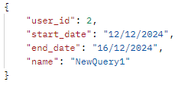
- Response:

- Test status: Passed

Test 15: POST-Orders-Graph
- Description: Send POST request to save new OrderingGraph type (3) query

- Correct response: Ok request (200) + Save confirmation:

- Request: ` http://127.0.0.1:5000/finas/user/query/orderingGraph`+ body:
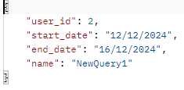
- Response:

- Test status: Passed

Test 16: POST-Orders-Graph
- Description: Send POST request to save new OrderingItemGraph type (4) query

- Correct response: Ok request (200) + Save confirmation:

- Request: ` http://127.0.0.1:5000/finas/user/query/orderingItemGraph`+ body:
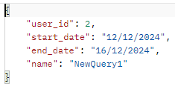
- Response:

- Test status: Passed

Test 17: Delete-Orders-Report
- Description: Send DELETE request to remove new OrderingReport type (1) query with the given id

- Correct response: Ok request (200) + Delete confirmation:

- Request: `http://127.0.0.1:5000/finas/user/query/orderingReport?user_id=1&id=2`:

- Response:
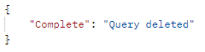
- Test status: Passed

Test 18: Delete-Orders-Graph
- Description: Send DELETE request to remove new OrderingGraph type (3) query with the given id

- Correct response: Ok request (200) + Delete confirmation:

- Request: `http://127.0.0.1:5000/finas/user/query/orderingGraph?user_id=1&id=1`:

- Response:
- Test status: Passed

Test 19: Delete-Orders-Items-Report
- Description: Send DELETE request to remove new OrderingItemReport type (2) query with the given id

- Correct response: Ok request (200) + Delete confirmation:

- Request: `http://127.0.0.1:5000/finas/user/query/orderingItemReport?user_id=1&id=1`:

- Response:
- Test status: Passed

Test 20: Delete-Orders-Items-Graph
- Description: Send DELETE request to remove new OrderingItemGraph type (4) query with the given id

- Correct response: Ok request (200) + Delete confirmation:

- Request: `http://127.0.0.1:5000/finas/user/query/orderingItemGraph?user_id=1&id=1

- Response:
- Test status: Passed

